AI Pioneers Internship: Week 3 Report
Name: Aquine Roshan Pais
Project Track: AI Pioneers Internship
Dataset: Credit Card Fraud Detection (10k Records)

1. Objective
The objective for Week 3 is to implement Unsupervised Learning techniques, specifically K-Means clustering, to discover hidden patterns in the transaction data. Additionally, we are performing advanced model evaluation and hyperparameter tuning using Cross-Validation and ROC-AUC on our supervised models.

2. Setup and Data Loading
We begin by importing the necessary libraries for clustering, dimensionality reduction, and evaluation.
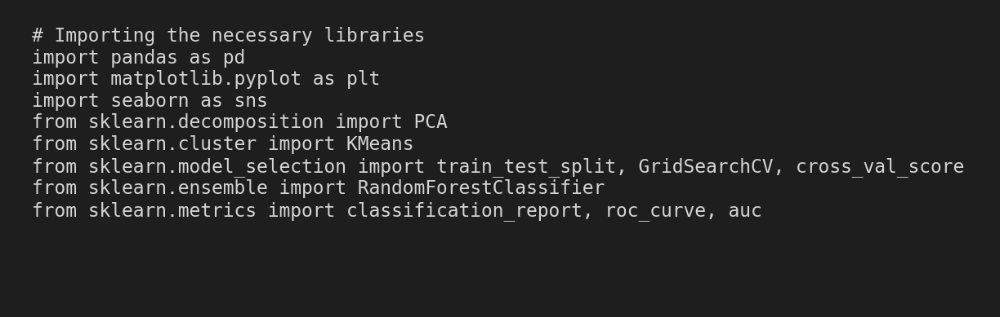

Next, we load the cleaned dataset from Week 1 and separate the features from the target variable.
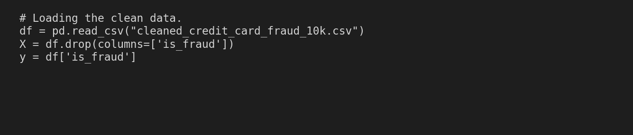

3. Dimensionality Reduction & K-Means Clustering
Because the dataset contains multiple features, it's impossible to visualize on a 2D plot. We use Principal Component Analysis (PCA) to compress the data into two principal components. Then, we apply the K-Means algorithm to group the transactions into 3 distinct behavioral clusters.
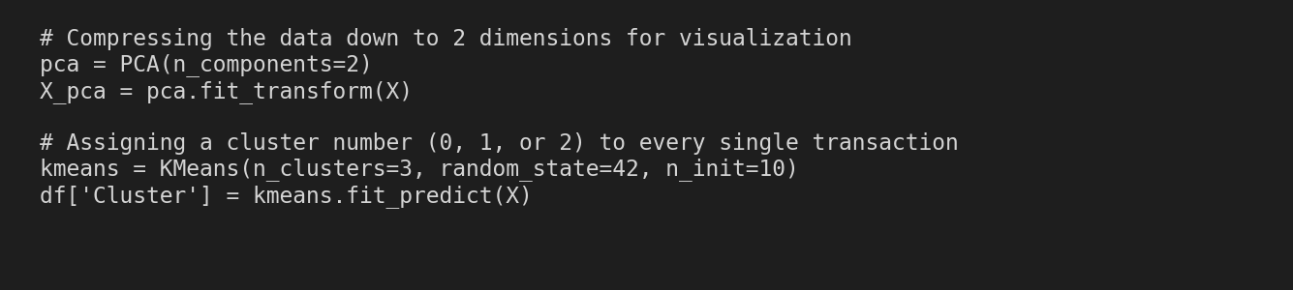

4. Advanced Model Evaluation Insights
Based on the classification report, our Random Forest model achieved a perfect precision of 1.00 for the fraud class, meaning zero false alarms. Although the recall is 0.52 (catching 52% of fraud), the model is extremely precise.
Cross-Validation provided scores ranging tightly from 0.991 to 0.998 across 5 folds, with an average ROC-AUC of 0.995. This demonstrates exceptional model stability and generalization to unseen data.
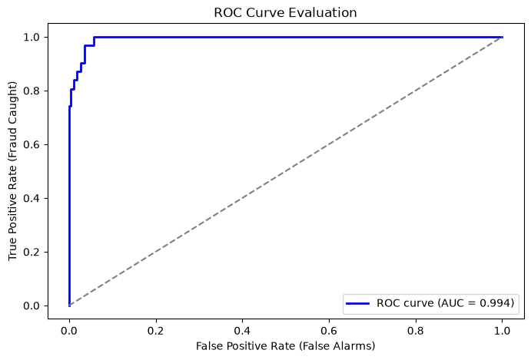

Finally, the ROC Curve yielded an AUC of 0.994, which is nearly perfect. This confirms the model's outstanding ability to distinguish between legitimate and fraudulent transactions. If a higher fraud catch rate (recall) is desired, the decision threshold could confidently be lowered.

